Contact Information:  The study staff is here to help and support you at any time. Please contact us between visits for any of the following reasons:  - If you experience any discomfort with the ring that cannot be resolved or have any other medical problems  - If the ring comes out or you take it out and have concerns about reinserting it, or any difficulties putting it back in  - If you cannot make your scheduled visit for any reason  - If your participation in the study causes problems with your partner, relatives, or other people or if they have any questions  - If you have questions about any of the information provided within this booklet  [site to insert contact information]  [Street Address]  [City, ST ZIP Code]  Phone: [Telephone]  Email: [Email address]  MTN-027 Information Booklet (v1.0_10Mar15) |  |  | MTN-027  IMPORTANT STUDY  INFORMATION

Important Information:  The researchers are conducting this research study to test vaginal rings that contain the study drugs vicriviroc (MK-4176), MK-2048, or a combination of vicriviroc/MK-2048 (MK-2048A). They are seeking to better understand if use of these rings over an approximate 28 day period is safe and how the study drugs enter and exit the body.  Your participation is voluntary; you do not have to join or remain in the study if you do not want to.  You will have a total of 13 visits (see visit schedule below). Most visits will last about 2 hours. Two visits, Enrollment and Day 28, will last longer (about 6-8 hours) because you will asked to provide additional samples of blood and vaginal fluid. While in the research study, you will be asked to insert a ring in your vagina and not remove it for about 28 days. The 28 day period of ring use will be followed by approximately 7 days of no ring use.  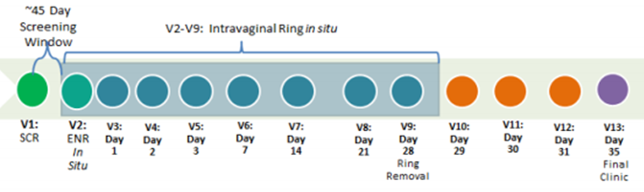  If you join, you will have an equal chance of being placed into 1 of 4 vaginal ring groups. One group will receive a placebo ring, which does not contain any study drug.  No matter which group you are in, you must remember that we do not know if the study drugs will protect women from getting HIV. There are two known ways to prevent HIV: using condoms and/or using an oral pre-exposure prophylaxis (PrEP). Study staff can provide you with additional information about these options. |  |  | Prohibited Activities and Products:  You cannot join this study if you are currently or have recently taken part in another study of drugs, medical devices or vaginal products. Please tell the study staff about any other studies you are taking part in or thinking of taking part in. You should also inform study staff of all medications you are taking or may take during the study. This is very important for your safety.  While in the study, you will be asked to avoid the following practices and medications:  - Receptive sexual activity (vaginal, anal, or oral sex or finger stimulation) or use of sex toys (such as vibrators, dildos, etc.) for the 5 days prior to your enrollment visit and for the duration of the study  - Tampons during the first week of participation (starting at your enrollment visit), and for 24 hours prior to each visit  - Use of non-study vaginal products and other devices for the 5 days prior to your enrollment and for the duration of the study. This includes, but is not limited to:  - Spermicides and female condoms  - Diaphragms and contraceptive rings  - Vaginal medications  - Menstrual cups or cervical caps  - Douches  - Lubricants  - Female-to-male transition medications  - CYP3A inhibitors and inducers (study staff will explain  what these are in more detail)  Engaging in these practices or using any of the above products while in the study may make the vaginal ring work differently. These products and practices could irritate the vagina or lead to a higher risk of you experiencing side effects.

